**BC2402: Designing and Developing Databases**

**SQL Exercises 2**

**Objectives**

For additional practice with SQL, figure out the following queries using the following ER diagram:

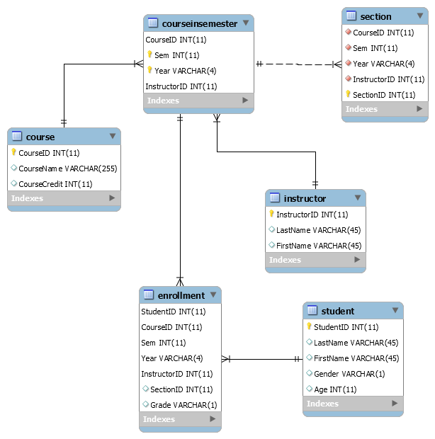

Refer to UniversityExport.sql

Develop and write the SQL statement that corresponds to the following queries:

1. Which students are enrolled with a last name ‘Ben’? Show their last names, first names, age, and gender. Order by gender, and then age.

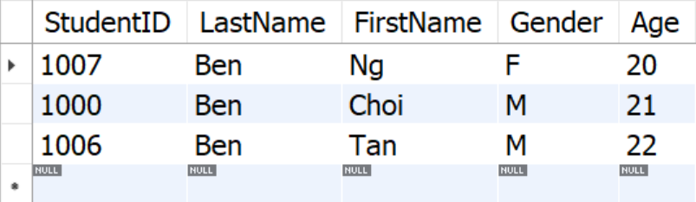

1. What are the studentIDs, first names, and last names of the students that have failed at least one course?

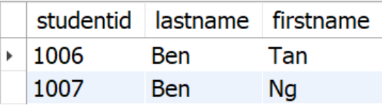

1. Which students (by studentID) have gotten a grade of ‘D’ or ‘F’ for at least one course?

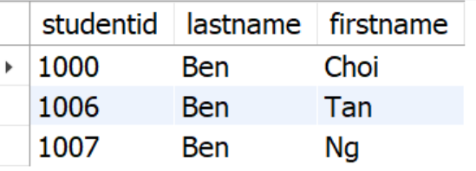

1. What are the studentIDs, first names and last names of the students who have been taught by John Chua? Sort the students in alphabetical order by last name.

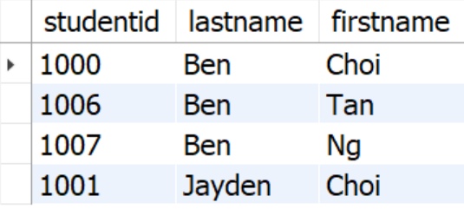

1. How many sections of any course has John Chua taught in Semester 2 2018?

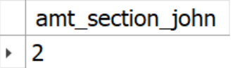

1. How many students are taking each section of 8881 taght by Kris Tan in Semester 1 2018?

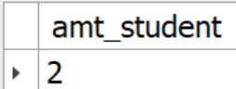

1. Which students (by name) have taken at least three courses from 2017-2018?

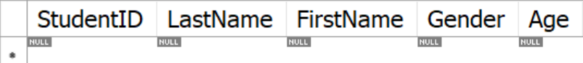

1. Which instructors teach at least 3 sections in Semester 2 2018?

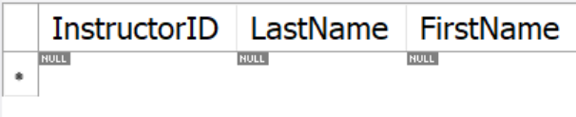

1. Which students (by name) have obtained at least 3 ‘A’ grades from 2017-2018?

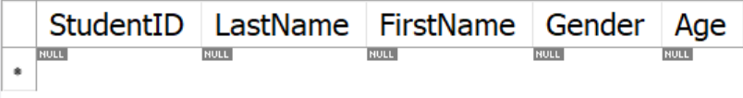

1. (Exploratory question) Create a new record for a new course called ‘Advanced Database Development’ (CourseID: 8887). The course has 4 course credits.
2. (Exploratory question) Add the instructor “WuShin Yi” with instructor ID 5507.
3. (Exploratory question) Add that ‘WuShin Yi’ teaches the section 15 for Advanced Database Development (couseID: 8887) in Semester 1 2018.
4. (Exploratory question) The course called ‘Advanced Database Development’ is to be recoded as ‘9887.’ (You can assume that cascade on update is implemented on FKs)
5. (Exploratory question) The instructor ‘John Chua’ is very generous. Every student in his class for 2018 Sem 1 is going to get an ‘A.’
6. Show all students who are not taking a course in Semester 2 2018.

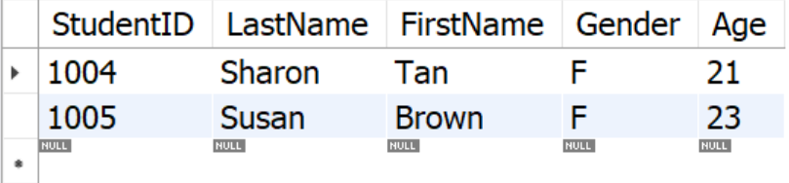

1. Show instructors who have never taught a course.

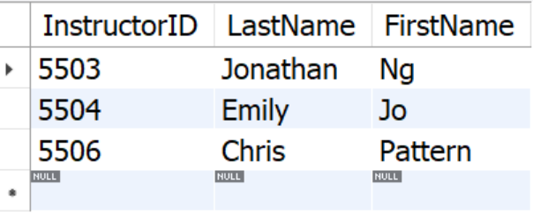

1. Count the number of courses each instructor has ever taught. Remember, some instructors can teach no classes.

